**Superstore Sales Performance - Capstone Project**

View 1: Total Sales

* The sheet should only display the Total Sales in thousands, along with the header “Total Sales”.
* The Total Sales displayed should have the color code “#76b7b2”. Use the Color Palette.
* Disable Tooltip for this view.
* Use the background color of your choice.
* Name the sheet as “Total Sales”.

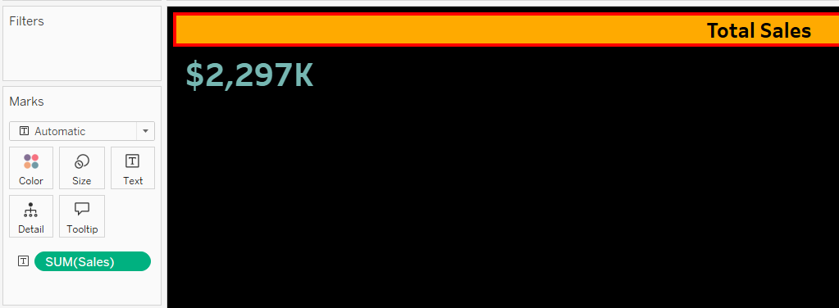

View 2: Total Profit

* Requirements are the same as for the view “Total Sales”.

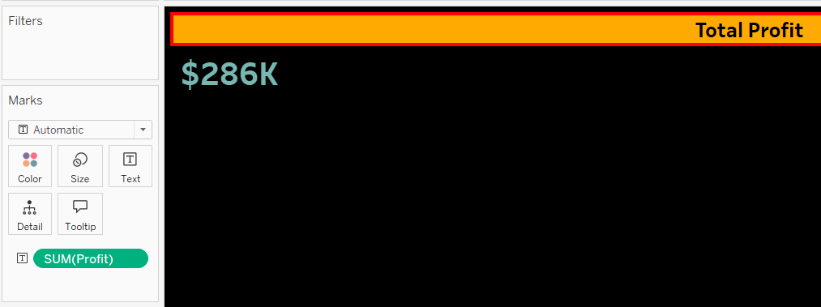

View 3: Total Volume

* Requirements are the same as for the view “Total Sales”, except it’s not a currency value.

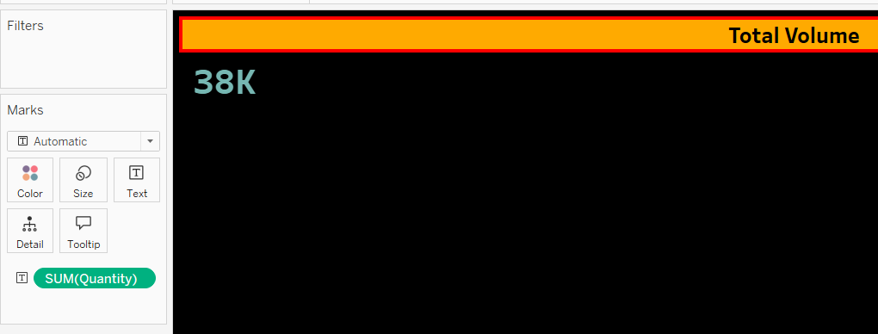

View 4: Sales Per Customer

* Requirements are the same as for the view “Total Sales“.

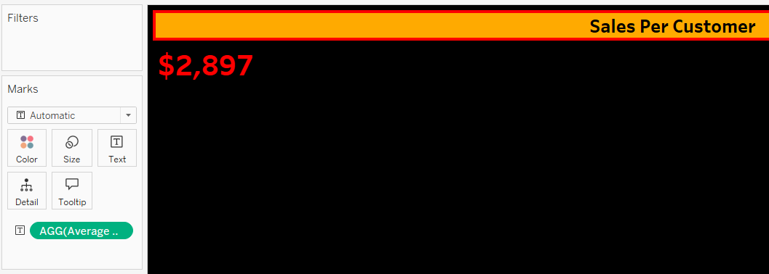

View 5: Pie Chart

* Pie Chart should display the percent of Total Sales by Region.
* Use the Summer Color Palette. Pie Chart should have black borders.
* Tooltip should be formatted as seen below showing Region Name, Percent of Total Sales, and the Total Sales value formatted in currency and displayed in thousands (K).

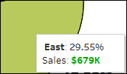Note: Drag all the filters mentioned in the general requirement to this sheet named Pie Chart.

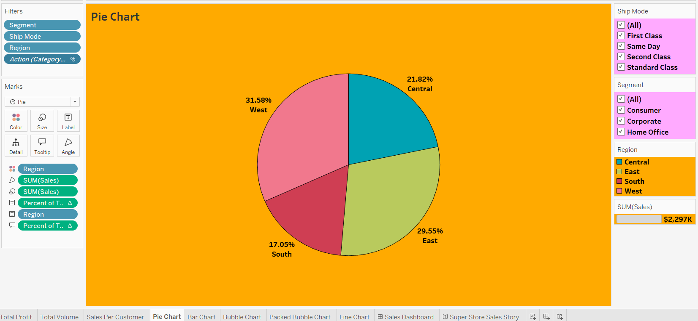

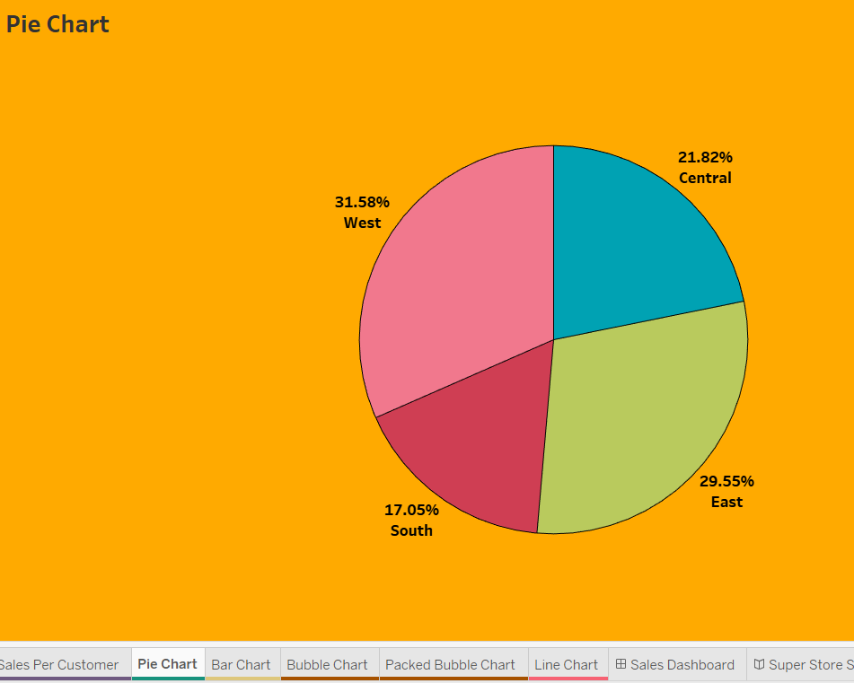

View 6: Bar Chart

* Horizontal Bar Chart should display the top N states by Sales.
* Using a Parameter, the user should be able to change the value of N.
* Use the color of your choice for the bars along with the labels displayed in $.
* Data should always be sorted in descending order.

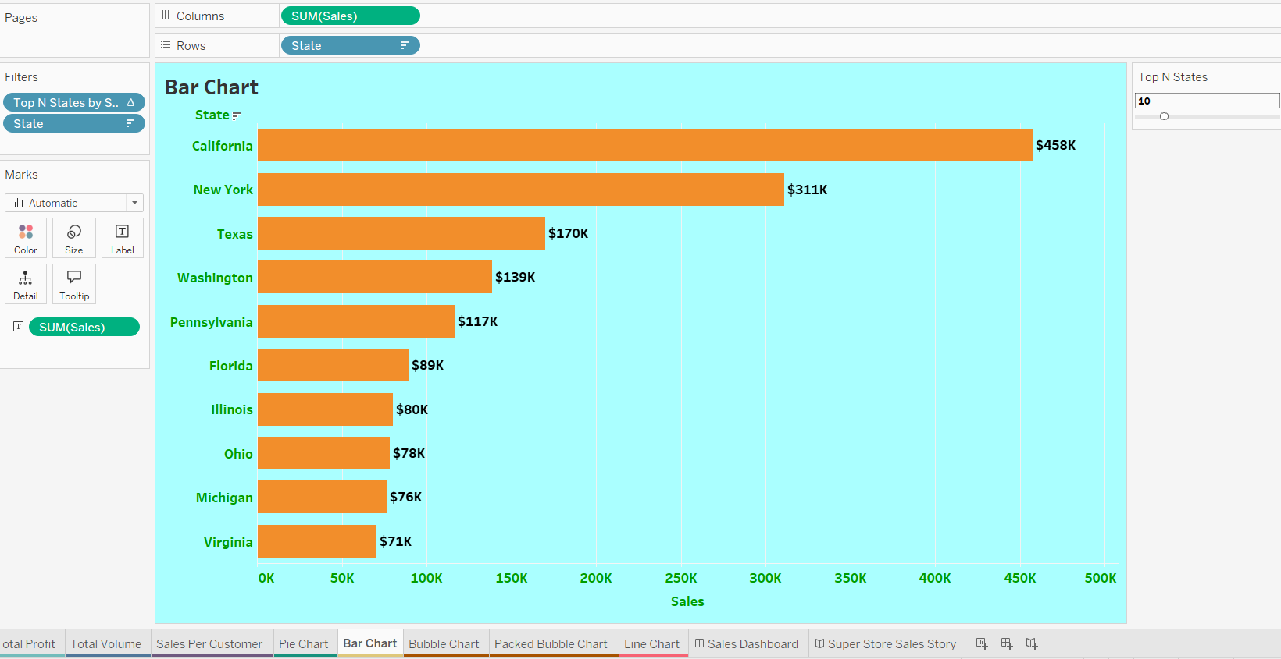

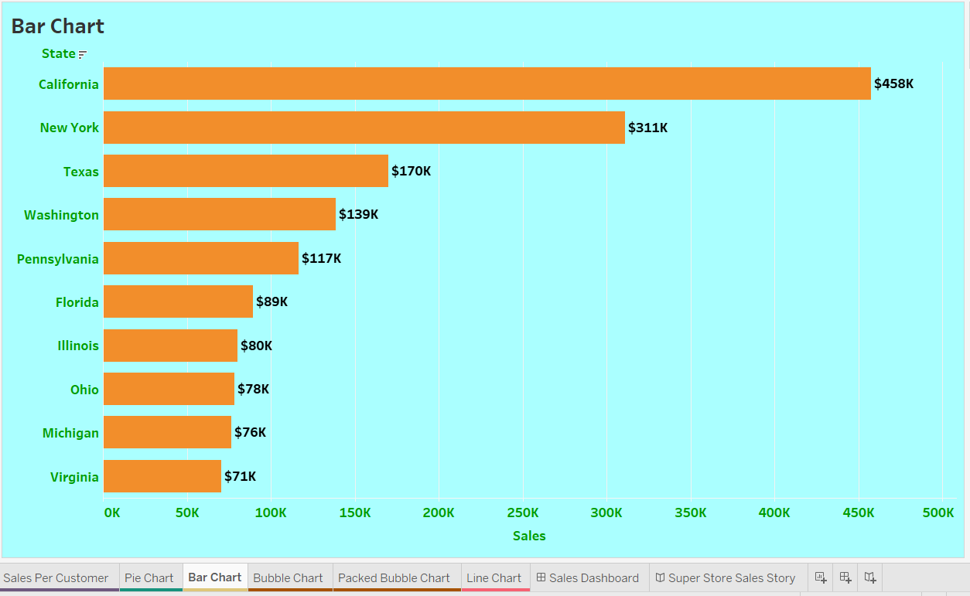

View 7: Bubble Chart

* Bubble chart should display Sales by sub-category.
* Bubbles should be colored by category.
* Use the color of your choice for the bubble.
* Tooltip should display only sub-category along with the sales value in $ in thousands (K).

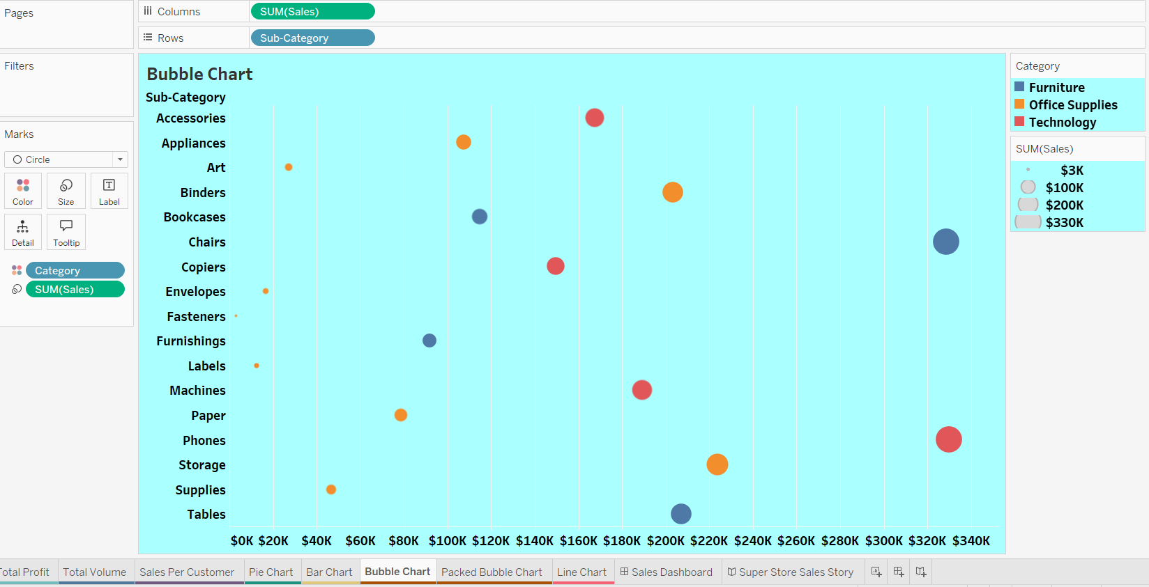

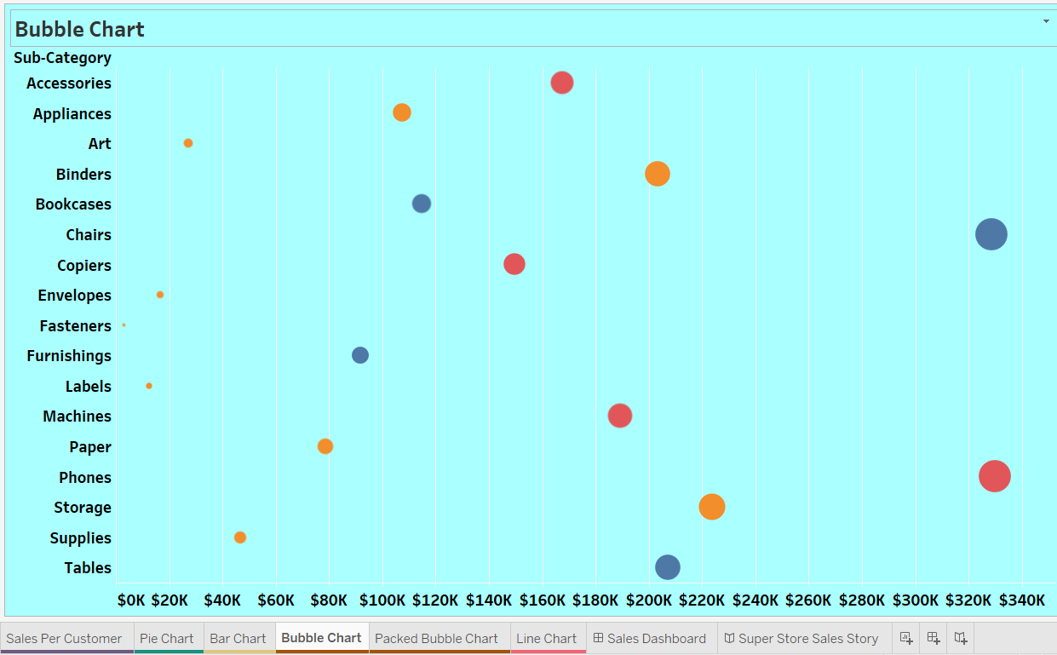

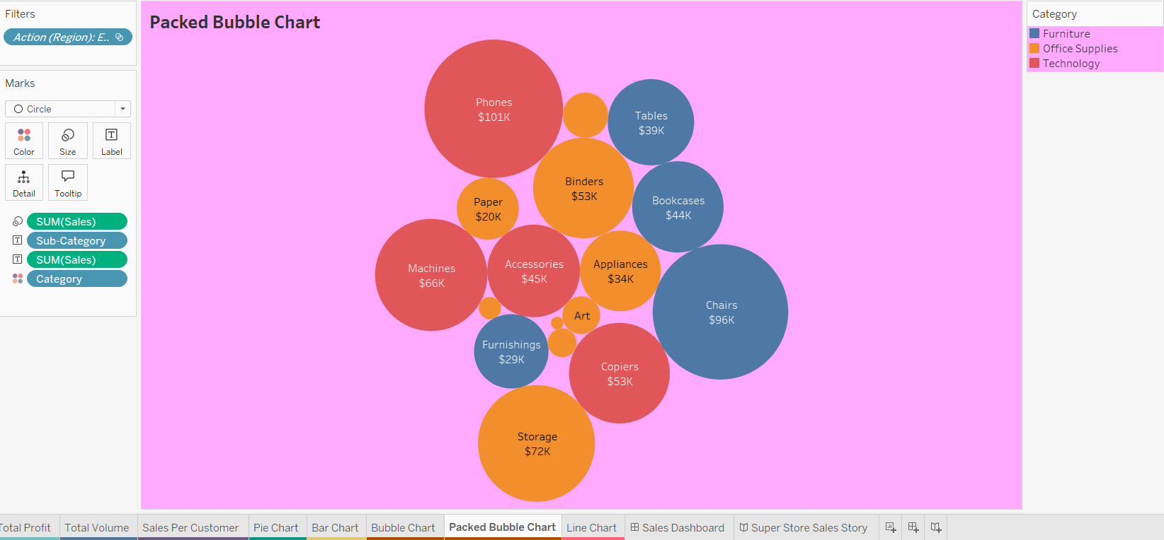

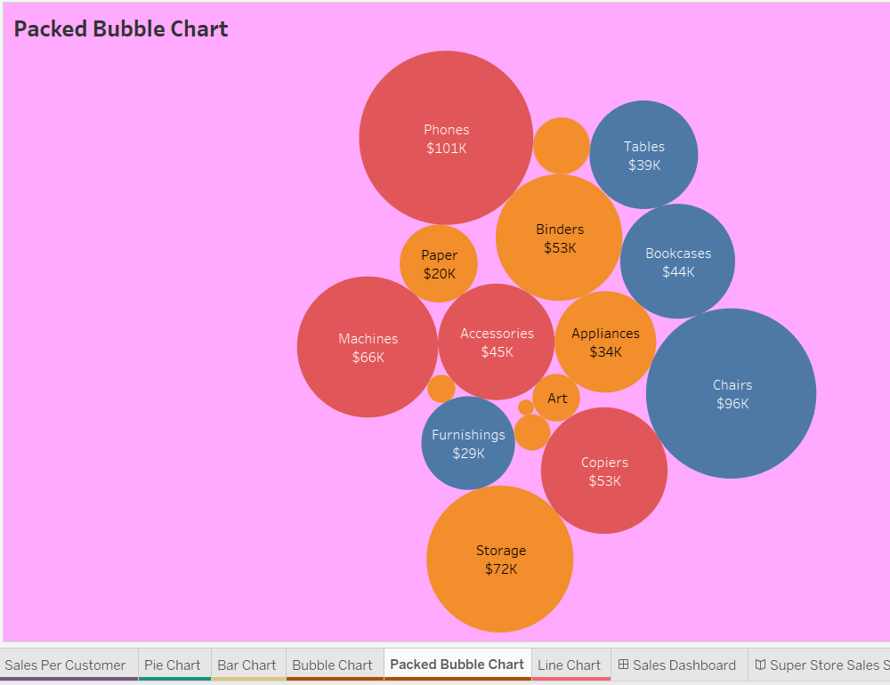

View 8: Line Chart

* A continuous line chart should display the Sales trend by Month-Year.
* X-axis should display month and year in the format MMM YY. For example, Mar 22 [Year 2022].
* Hide the axis titles only.
* Tooltip should display only Month-Year, along with the sales value in $ in Thousands (K).
* Use Order Date as a Date Range filter.
* Name the sheet as shown below and color the tab.

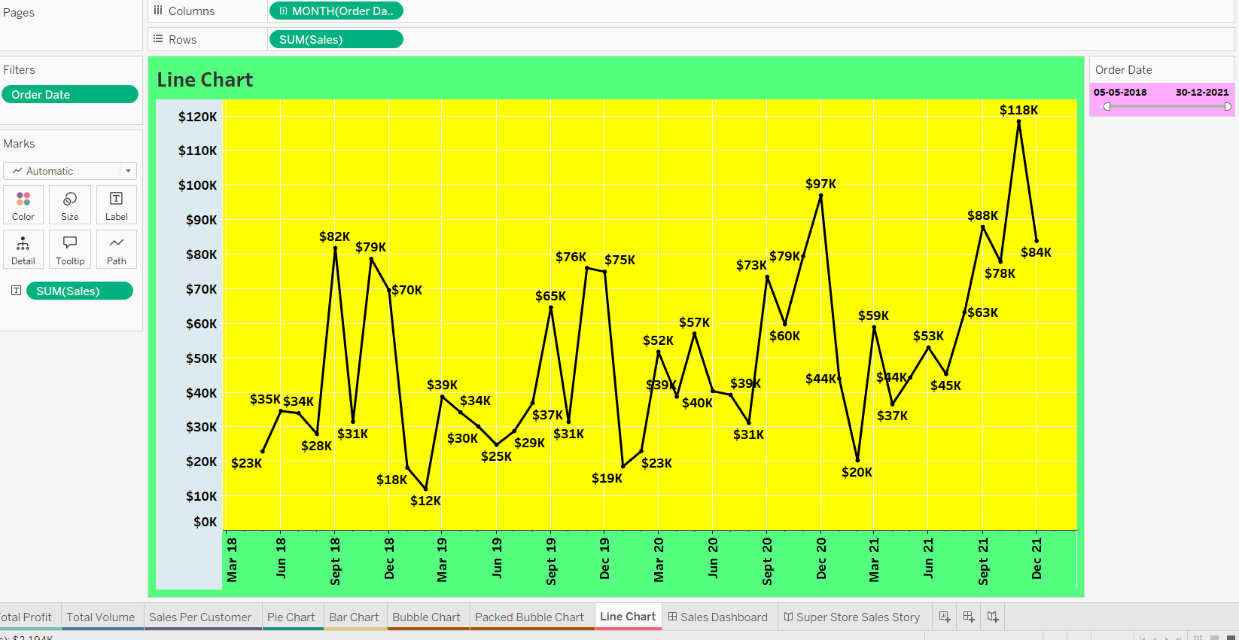

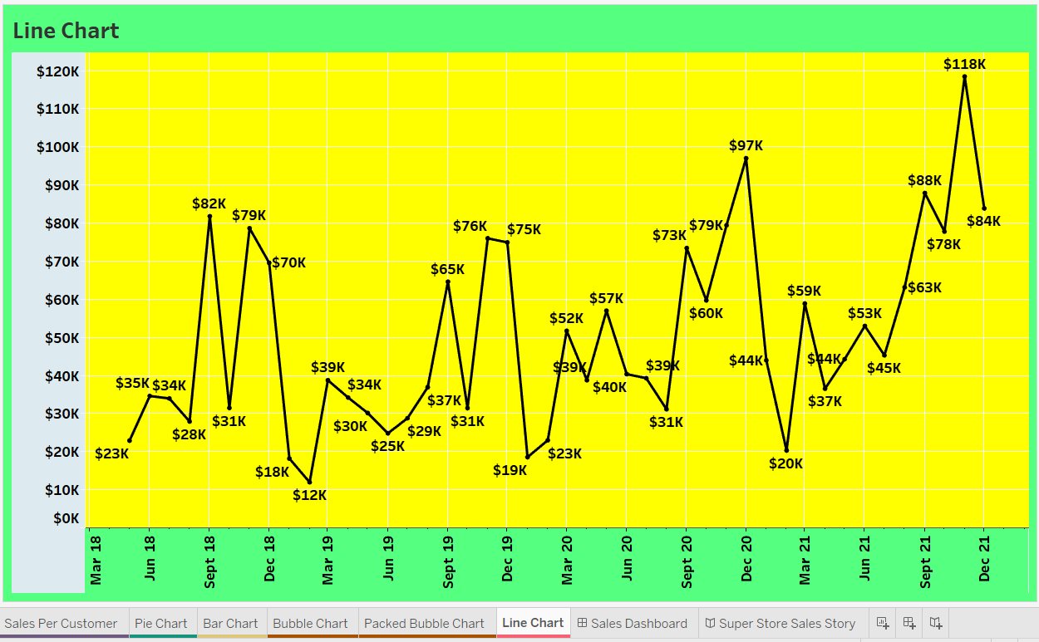

**Sales Dashboard**

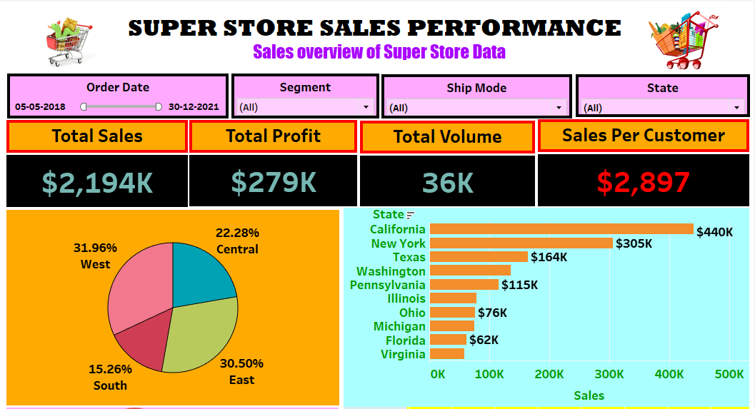

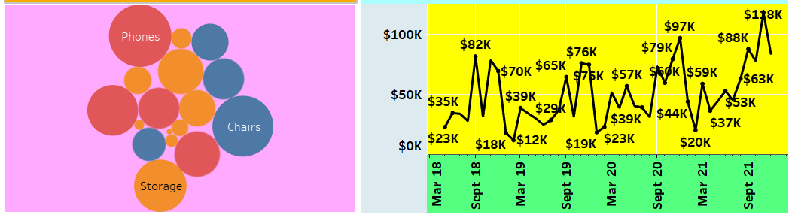

**Super Store Sales Story**

